

SCHOOL OF COMPUTER ENGINEERING AND TECHNOLOGY

DISCRETE STRUCTURES AND GRAPH THEORY

**Mini Project Assignment 3**

**Group Members :**

**Aniket Sulke**

**Rushabh Bokade**

**Gaurav Mahto**

According to set theory relevant mathematical model for our project is designed as follows-

Let,

* Set S = {I, P, q0, O, F}

where,

S is Health monitoring and service system

{I} is set of Input.

{P} is set of Process.

{q0} is set of Initial state/condition.

{O} is set of Output.

{F} is set of Final state/condition.

* Input I = {I1, I2, I3, I4, I5}

Where,

I1 is Input of Name.

I2 is Input of Weight.

I3 is Input of Blood pressure.

I4 is Input of Age.

I5 is Input of Symptoms.

* Process P = {P1, P2, P3, P4, P5,}

Where,

P1 is Process of Registration.

P2 is Process of Treatment.

P3 is Process of anesthesia.

P4 is Process of Medicine Remainder.

P5 is Process of Take Feedback Every-day.

P6 is Process of Store data.

* Initial State q0 = {q01}

Where,

q01 is initial condition of patient before having treatment.

* Output O = {O1}

Where,

O1 is cure advice given to patient.

* Final State F = {F1}

Where,

F1 is Final condition of patient after completion of treatment.

* **VENN DIAGRAM :**

I P O

P2

P3

P4

P5

P6

P1

I1

I2

I3

I4

I5

O1

* 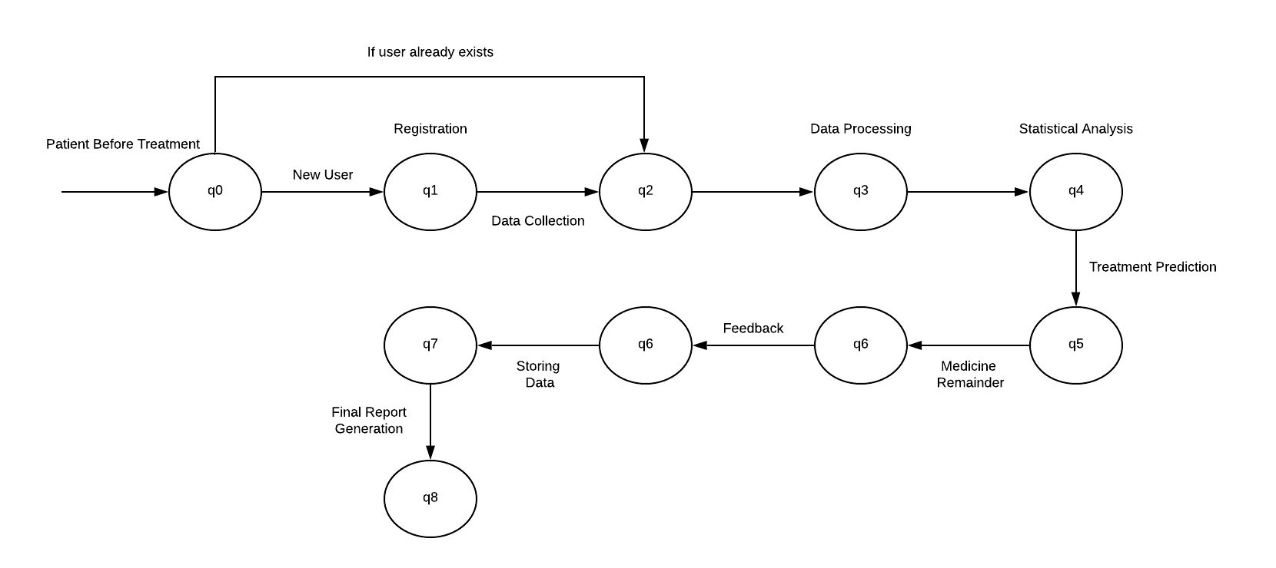**Process State Diagram :** This diagram represents the various states of system. Here q0 is the initial state.